**Introduction**

For every final product, validating that safety requirement are completely covered and met, is a crucial part to product development. For this to be ensured possible hazards posed by the system must be evaluated and safety requirements must be established. There are different tools from project management and LEAN SIX SIGMA disciplines, that can be used: this includes FMEA(Failure Mode and Effects Analysis), Kaizens, Cause and Effects matrices and others. For determining hazards of the RXsim, a FMEA was used. Throughout the following document considerations were meticulously evaluated to ensure safety across all potential system states for both the user and system.

# **Purpose**

The purpose of this document is to provide detailed descriptions and solutions the potential hazards that might affect the performance and safety of RXSim and its users. These hazards are evaluated across the different states that the system can be in. The document must encompass a comprehensive coverage of all the potential safety hazards.

# **Overview**

## **Component Overview**

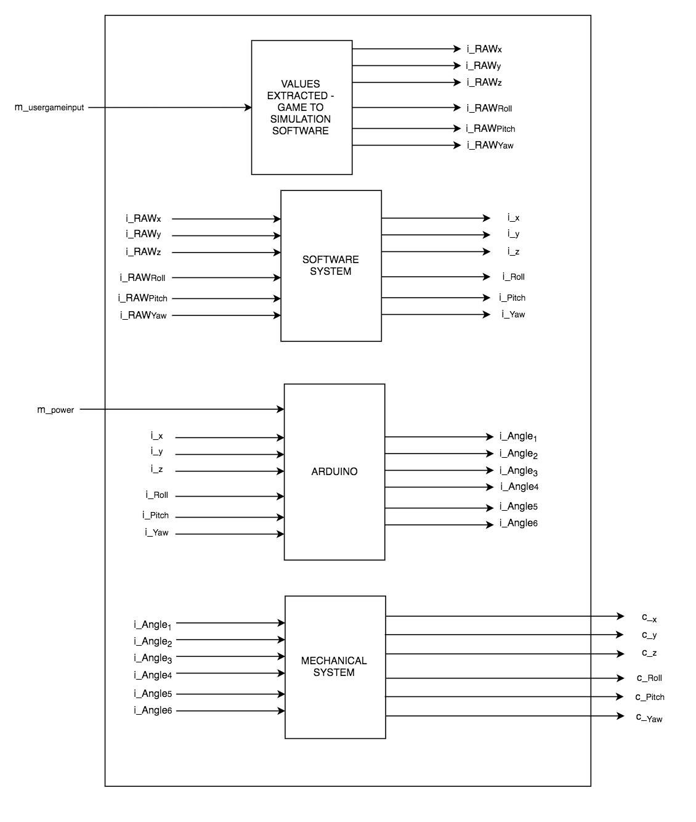

## **Component Description**

Values Extracted - Game to Simulation Software

The user input to the game controls the vehicle in the video game. This causes forces on the vehicle as it’s accelerating in different directions. The simulation software profile determines the force values to be extracted.

Software System

The force values that are extracted are formatted to be sent serially to the Arduino by the simulation software.

Arduino

An Arduino microcontroller is used to translate the data from the simulation software to the required angle on the servo motors. Then it sends a signal to the servo motors to position them.

Mechanical System

The mechanical system is comprised of all the servo motors, rods, joints, and the platform. Servo motors move the platform through the connected rods.

# **Safety Considerations**

The safety of the primary and secondary users is very important therefore many considerations have been taken to determine the modes of failure that can be harmful to these users. The laptop associated with RXSim is not within the scope of the hazard analysis. However, users who will be using this system should be aware of the safety concerns associated with the normal modes of operation. The hazards associated with RXSim can be seen below with a description of the issues and solutions to the problem.

## **Loss of Power**

*Issue:*

RXSim loses power and can no longer communicate with the Arduino.

*Solution:*

A hardware safety circuit will be implemented to protect circuits from sudden changes in voltages.

## 

## 

## 

## **Moving Parts Hazard**

*Issue:*

There are many actuators and moving parts which drive the motion of the RXSim platform. If the user gets too close to RXsim, there is a possibility that the user’s fingers, jewelry, or clothing can get caught in the moving parts.

*Solution:*

The base of RXSim has been designed to minimize the exposure of moving parts to the user. Warning signs will also be placed near RXSim to ensure that the user is aware of the hazard of moving parts.

## **Heat Hazard**

*Issue:*

The electrical circuits and actuators involved in RXSim’s operation can become hot during use which can create a risk of injury if the user makes contact with these components.

*Solution:*

The electrical components of RXSim will be sectioned off from the user to prevent any accidental or intentional contact. However, the actuators will be exposed due to the design of RXSim. A written warning will be placed near the base of RXSim to warn users of potential high temperatures within the components of the system.

## **Loose Wire Hazard**

*Issue:*

Loose/exposed wires can create electrocution hazards for the user.

*Solution:*

All circuitry for RXSim will be sectioned off from the user. Any wires that are exposed outside of this enclosure will be organized and tied down or mounted to ensure that there is no threat of a wire coming loose.

## **Loose Screw Hazard**

*Issue:*

RXSim has many moving parts which need to move in parallel to achieve the desired movement. If one part is loose, it poses a risk to both the user and the system as a whole.

*Solution:*

All joints will be periodically tightened.

**FMEA Worksheet**

|  |  |  |  |  |  |  |  |  |
| --- | --- | --- | --- | --- | --- | --- | --- | --- |
| **Design Function** | **Failure Modes** | **Effects of Failure** | **Causes of Failure** | **Detection** | **Control** | **Recommended Action** | **SR** | **Ref** |
| Values Extracted - Game to Simulation Software | Values are not extracted from video game | No movement of system | a. Missing connection to video game  b. Software not running  c. Profile not loaded | Software check | Ensure all connections are valid    Load profile on each launch of simulator | Stop simulation then reload profile and relaunch video game |  |  |
|  | Incorrect values extracted from video | Incorrect movement of system | 1. Incorrect profile loaded | Simulator profile check | Load profile on each launch of simulator  Follow naming convention to establish latest profile being used | Stop simulation then reload correct profile and relaunch video game |  |  |
| Software System | Values are not correctly formatted | Incorrect movement of system | 1. Incorrect profile loaded | Simulator profile check | Load latest profile on each launch of simulator  Follow established format for data information | Stop simulation then reload correct profile and relaunch video game |  |  |
|  | Values are not sent serially | No movement of system | 1. Incorrect profile loaded 2. USB port malfunction 3. Broken wire | Simulator profile check  Physical check of hardware and wiring | Load latest profile on each launch of simulator | Stop simulation then reload correct profile and relaunch video game  Change wire or USB port |  |  |
| Arduino | Microcontroller malfunction | No movement of system | Spikes in voltages | Software check and Visual detection | Use separate power sources for motors and the Arduino | Unplug USB from computer and remove battery source |  |  |
|  | Wire break | No movement of system | User tampering with system; loose wire gets caught in moving parts | Visual detection | Check all wires prior to system start; ensure there are no loose wires that can be snagged by moving parts | Remove power supply from Arduino and motors replace or replug damaged wires |  |  |
| Mechanical System | A platform leg falls off  Motor becomes loose from housing  Leg is unattached to motor | Platform becomes lopsided or collapses | Loose fastener | Visual detection | Ensure all joints are properly fastened prior to system start; limit the maximum speed and orientations of the platform to prevent strain on joints and platform legs during operation | Stop the all movement of RXSim until joint fasteners have been tightened and/or platform legs have been repaired |  |  |

# 

# 

# **Conclusion**

A thorough hazard analysis was conducted at the current development stage to ensure user safety along with system safety. The FMEA approach was chosen to document a list of considerations to further improve RXSim’s design iterations. The safety of RXSim and its users is very important Next Generation Solutions (NGS) and many precautions have been taken to mitigate hazards. Due to time and budget constraints it will be hard to remove all the potential hazards. Through this hazard analysis NGS will ensure RXSim complies to safety standards throughout the development of RXSim.